# Ex No 10

Visualize Data using Any plotting Framework

# AIM:

To Visualize Data using Any plotting Frame work using R programming.

# PROCEDURE:

* Install Plotly using pip install plotly if it’s not already installed.
* Import the necessary libraries: import plotly.express as px and import pandas as pd.
* Load your dataset into a DataFrame using pd.read_csv() or other data loading methods.
* Explore the dataset to understand its structure, variables, and potential visualizations.
* Choose the appropriate Plotly function (e.g., px.scatter, px.bar,px.line) based on the type of data and the desired plot.
* Define the x and y axes by specifying the columns from the DataFrame.
* Customize the plot by adding titles, labels, color coding, and other plot-specific attributes.
* Add interactive elements like hover data, tooltips, or facet plots for deeper insights.
* Render the plot using fig.show() to display it in a web browser or inline in a notebook.
* Save the plot to an HTML file or as a static image using fig.write_html() or fig.write_image().

# CODE:

**Scatter Plot.R:**

# Install ggplot2 (if not already installed) install.packages("ggplot2")

# Load the ggplot2 package library(ggplot2)

# Scatter plot of Sepal.Length vs Sepal.Width, colored by Species ggplot(data = iris, aes(x = Sepal.Length, y = Sepal.Width, color = Species)) + geom_point(size = 3) + # Adds points

labs(title = "Scatter Plot of Sepal Dimensions", x = "Sepal Length (cm)",

y = "Sepal Width (cm)") + # Adds axis labels and title theme_minimal() # Applies a minimal theme

# Bar Chart.R:

# Install ggplot2 (if not already installed) install.packages("ggplot2")

# Load the ggplot2 package library(ggplot2)

# Bar plot of Species counts ggplot(data = iris, aes(x = Species)) +

geom_bar(fill = "steelblue") + # Adds bars filled with steel blue color labs(title = "Count of Different Species in Iris Dataset",

x = "Species", y = "Count") +

theme_minimal()

# Histogram.R:

# Install ggplot2 (if not already installed) install.packages("ggplot2")

# Load the ggplot2 package library(ggplot2)

# Histogram of Sepal Length

ggplot(data = iris, aes(x = Sepal.Length)) +

geom_histogram(binwidth = 0.3, fill = "orange", color = "black") + # Adds histogram bars

labs(title = "Histogram of Sepal Length", x = "Sepal Length (cm)",

y = "Frequency") + theme_minimal()

# Box Plot.R:

# Install ggplot2 (if not already installed) install.packages("ggplot2") library(ggplot2)

# Box plot of Sepal Length for each Species

ggplot(data = iris, aes(x = Species, y = Sepal.Length, fill = Species)) + geom_boxplot() + # Adds box plot

labs(title = "Box Plot of Sepal Length by Species", x = "Species",

y = "Sepal Length (cm)") + theme_minimal()

# OUTPUT:

**Scatter Plot:**

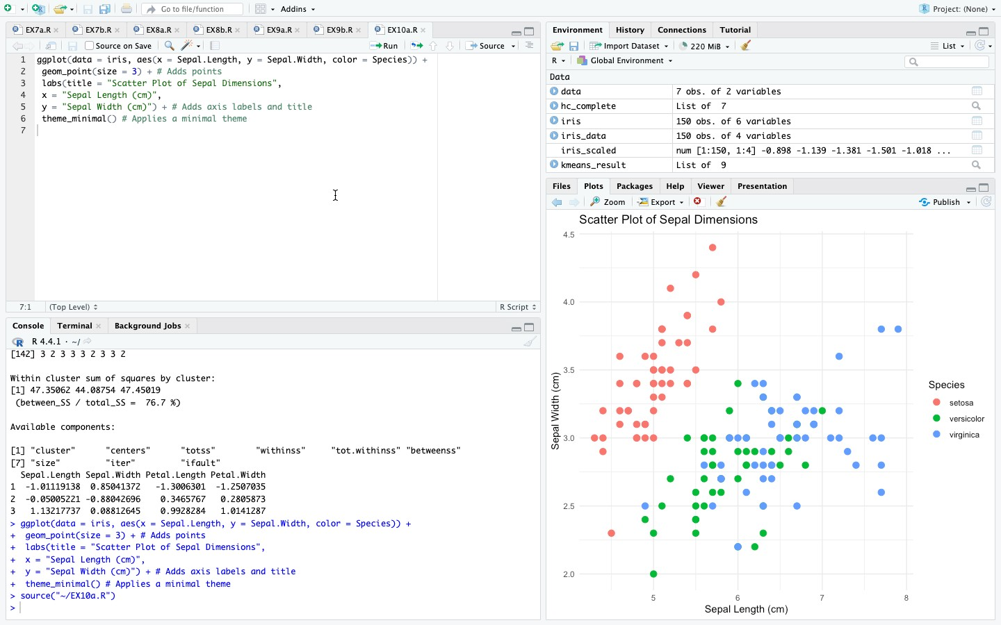

# Bar Chart:

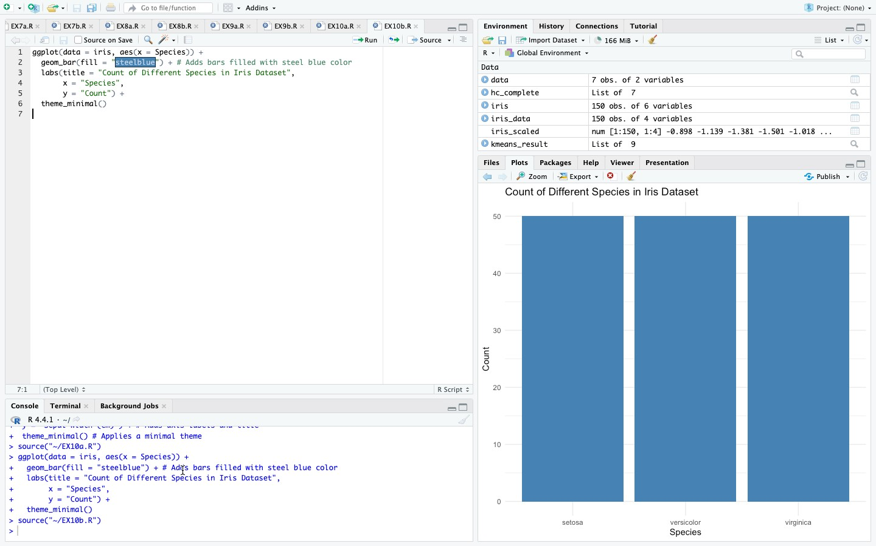

**Histogram:**

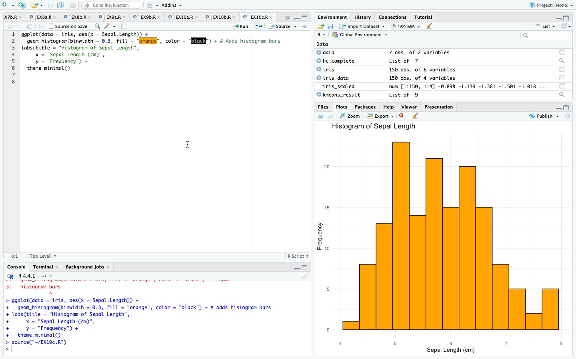

# Box Plot:

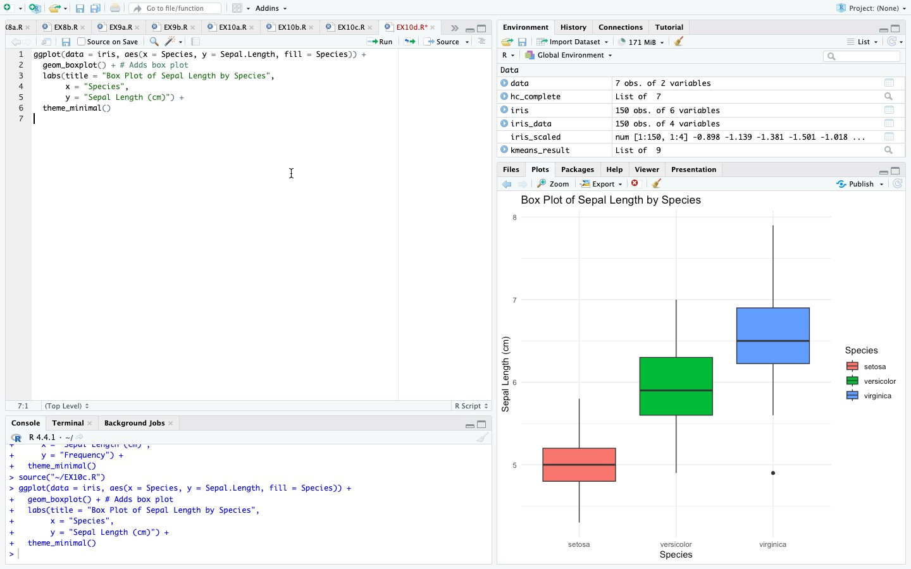

**RESULT:**

Thus, Visualizing Data using any plotting framework using R programming has been successfully executed.